Digital Modulation Techniques and Their Simulation Using Python

Name: Dhananjay Sharma (549)

Anuj Shinde (550)

Om Shinde (551)

Pratik Shinde (552)

Aim: To understand the principles of digital modulation techniques: **Amplitude Shift Keying (ASK), Frequency Shift Keying (FSK), and Phase Shift Keying (PSK)**.

Software Required: Google Colab

Theory:

In digital communication, information such as text, audio, or video must be transmitted efficiently from one point to another. However, digital signals (composed of 1s and 0s) cannot be directly transmitted over long distances because of **attenuation**, **noise**, and **bandwidth limitations** of the channel.  
To overcome this, we use **modulation**, which involves varying one or more parameters of a **high-frequency carrier wave** (such as its amplitude, frequency, or phase) according to the instantaneous value of the digital message signal.

**Types of Modulation:**

1. **Analog Modulation:** AM, FM, PM
2. **Digital Modulation:** ASK, FSK, PSK, QPSK, QAM, etc.

1) Amplitude Shift Keying (ASK)   
In **ASK**, the **amplitude of the carrier wave** is varied according to the binary data signal, while the **frequency and phase remain constant**.  
Binary ‘1’ is represented by transmitting the carrier signal, and binary ‘0’ by transmitting no carrier (or a lower amplitude carrier).

**Mathematical Expression:**

Where:

* : Modulated signal
* : Carrier amplitude
* : Digital message (1 or 0)
* : Carrier frequency
* : Time

The signal’s amplitude switches between a high and low level corresponding to the binary bits. This form of modulation is also called **On-Off Keying (OOK)**.

Applications:

* Optical fiber communication
* Early telephone modems
* RFID systems

2) Frequency Shift Keying (FSK)

In **FSK**, the **frequency** of the carrier wave is varied according to the digital input signal, while amplitude and phase remain constant.

Two distinct carrier frequencies are used:

* for binary ‘1’
* for binary ‘0’

**Mathematical Expression:**

Where:

* : Amplitude of the carrier
* : Frequencies for binary symbols
* : Binary message signal
* : Time

Whenever the digital input changes, the frequency of the carrier switches between and . This produces a waveform with alternating frequencies depending on the transmitted bits.

**Applications:**

* Radio and wireless communications
* Bluetooth and paging systems
* Caller ID systems

3) Phase Shift Keying (PSK)

PSK is a digital modulation technique in which the phase of the carrier is changed according to the binary data, while amplitude and frequency remain constant.

**Mathematical Representation:**

Where = 0° for binary 1 and 180° for binary 0 (Binary PSK, BPSK).

**Example:**

* Binary 1 → Phase = 0°
* Binary 0 → Phase = 180°

**Applications:**

* Wi-Fi (802.11 standards)
* Satellite communication
* Digital TV and secure data transmission

Procedure:

1. Generate a binary data sequence (e.g., [1, 0, 1, 1, 0]) in Python.
2. Define **sampling frequency**, **carrier frequency**, and **time vector** using NumPy.
3. **ASK Simulation:** Multiply binary data with the carrier (cos(2πf_ct)), plot the waveform using Matplotlib, and observe amplitude variations.
4. **FSK Simulation:** Assign two carrier frequencies for 0 and 1, generate the waveform, plot, and observe frequency shifts.
5. **PSK Simulation:** Apply phase shifts to the carrier (0° for 1, 180° for 0), generate waveform, plot, and observe phase changes.
6. Compare ASK, FSK, and PSK waveforms to analyse differences in amplitude, frequency, and phase.

Observation:

1. **ASK:** Amplitude clearly changes according to binary data.
2. **FSK:** Frequency shifts are distinct and observable.
3. **PSK:** Phase reversals occur precisely at binary transitions.

Conclusion:

1. **Modulation** enables efficient transmission of digital data over analog channels.
2. **ASK** is simple but easily affected by noise.
3. **FSK** offers better noise immunity but uses more bandwidth.
4. **PSK** is highly reliable and preferred in modern systems.
5. Understanding these techniques is key to digital communication design.

.

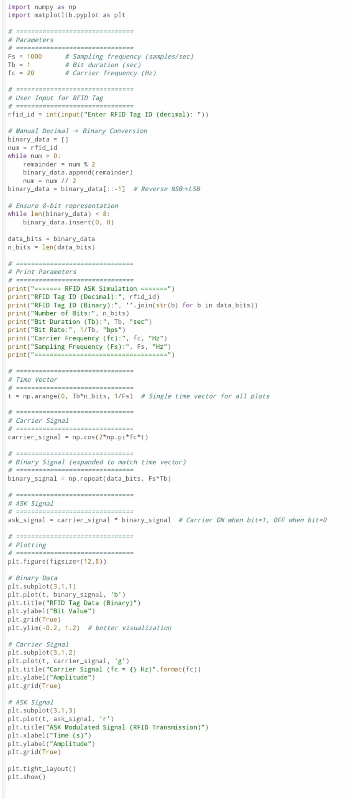

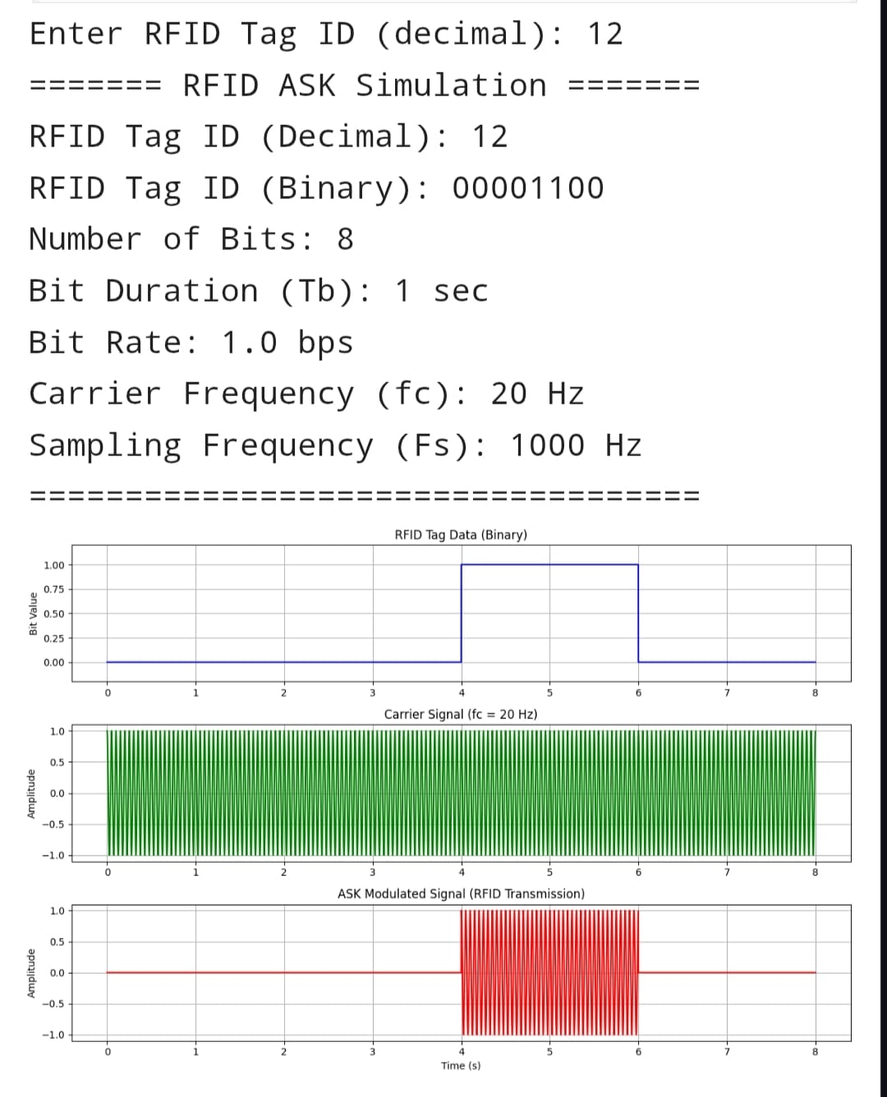

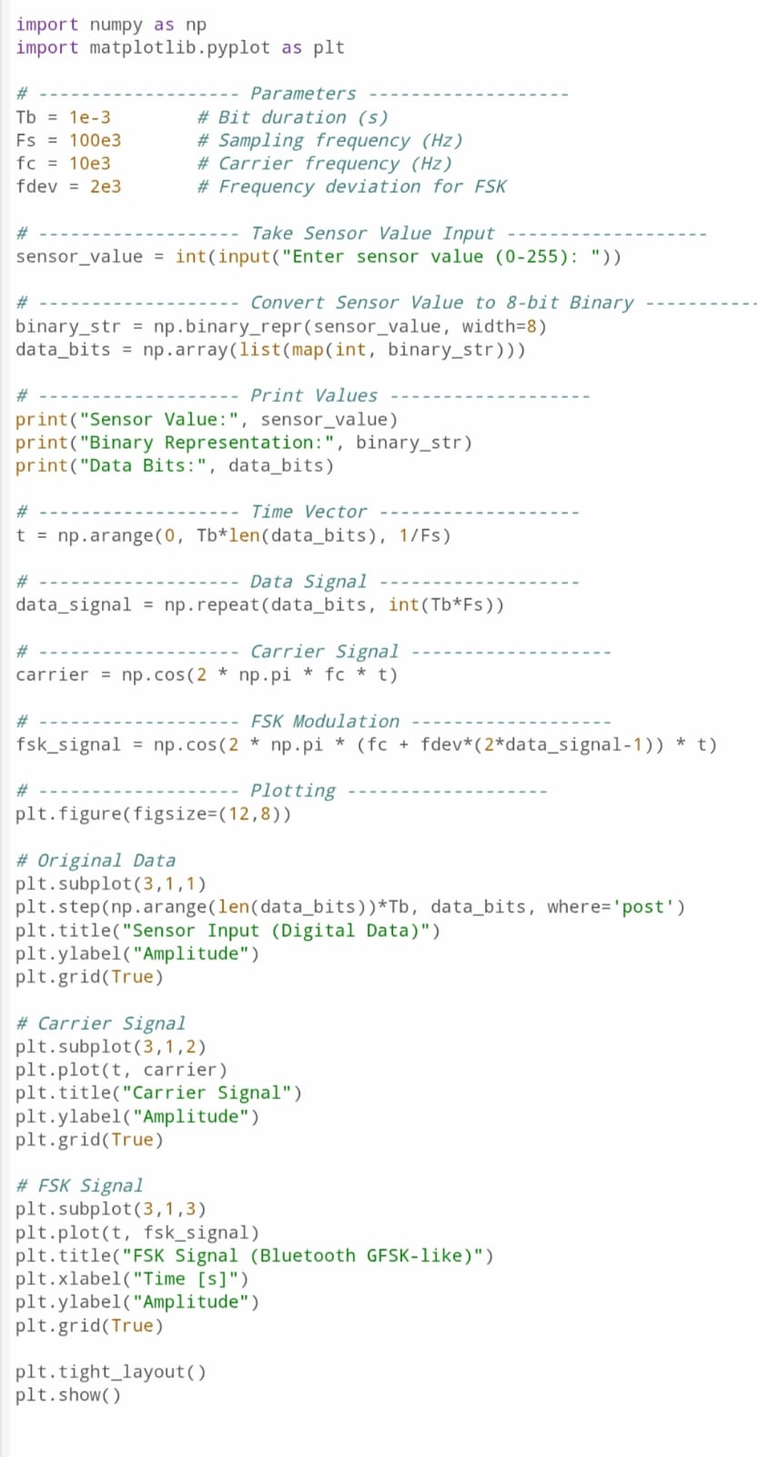

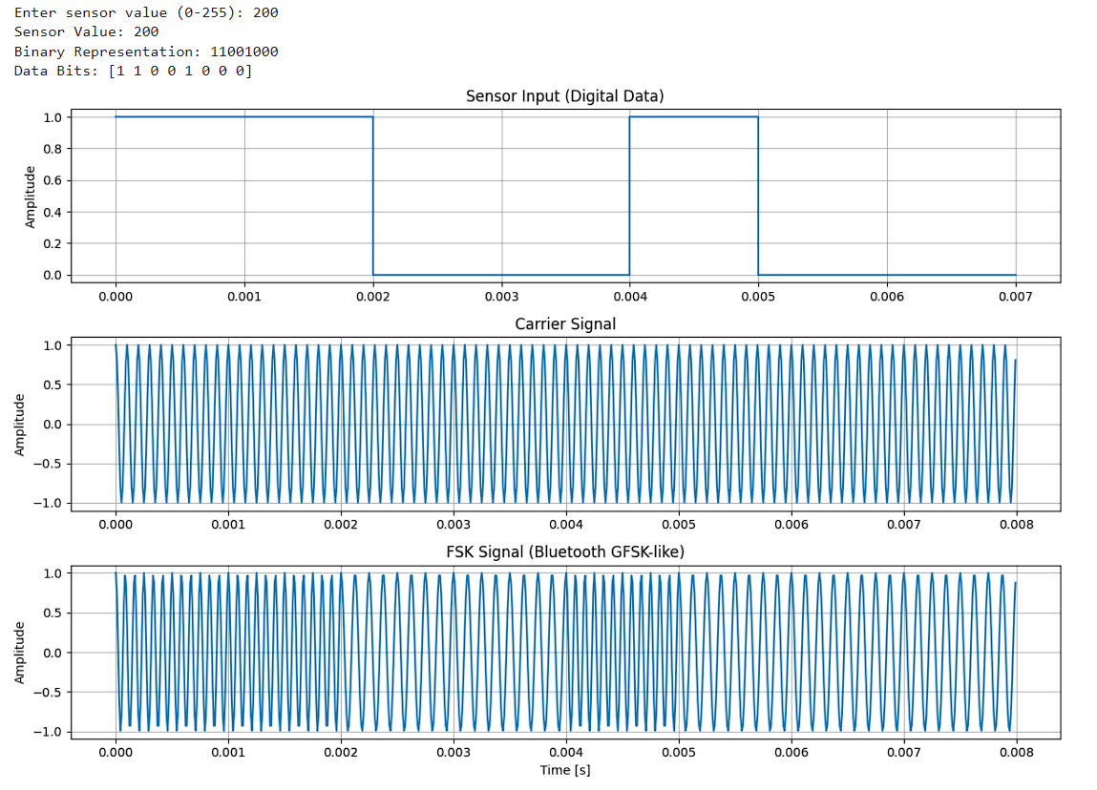

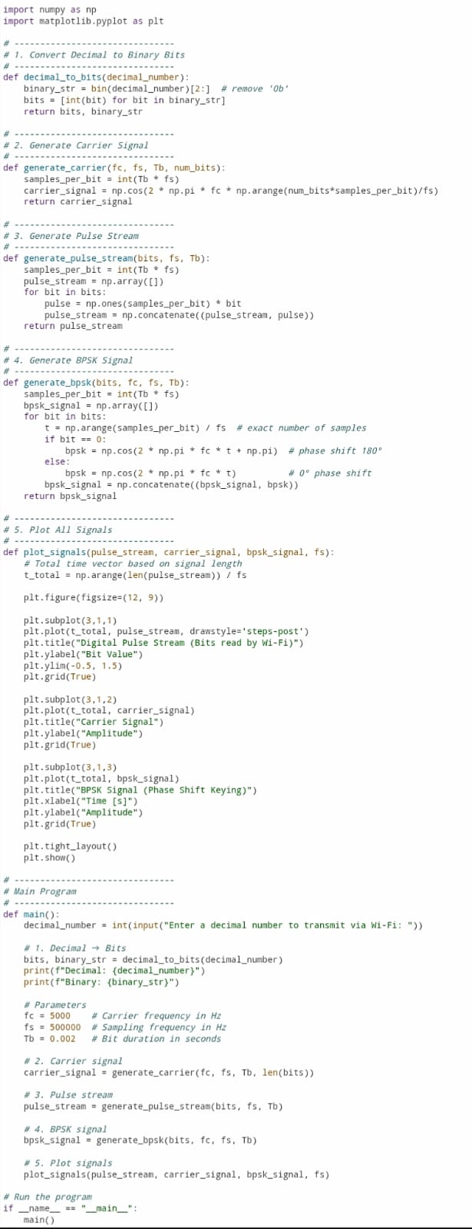

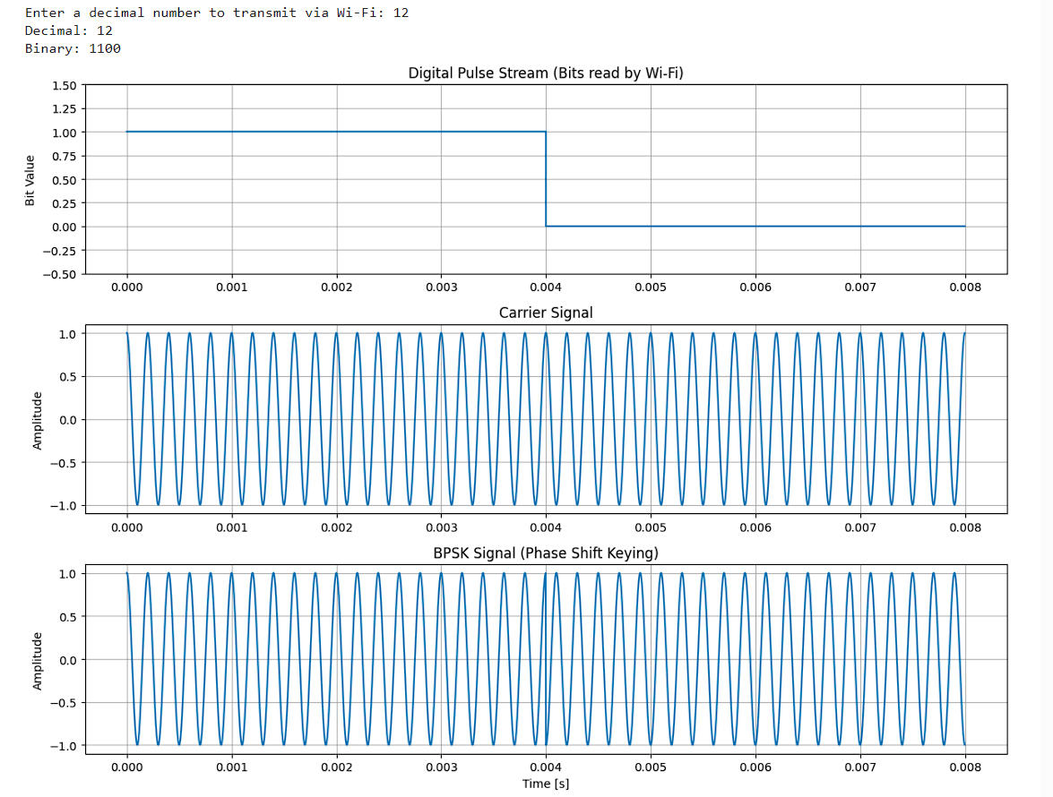

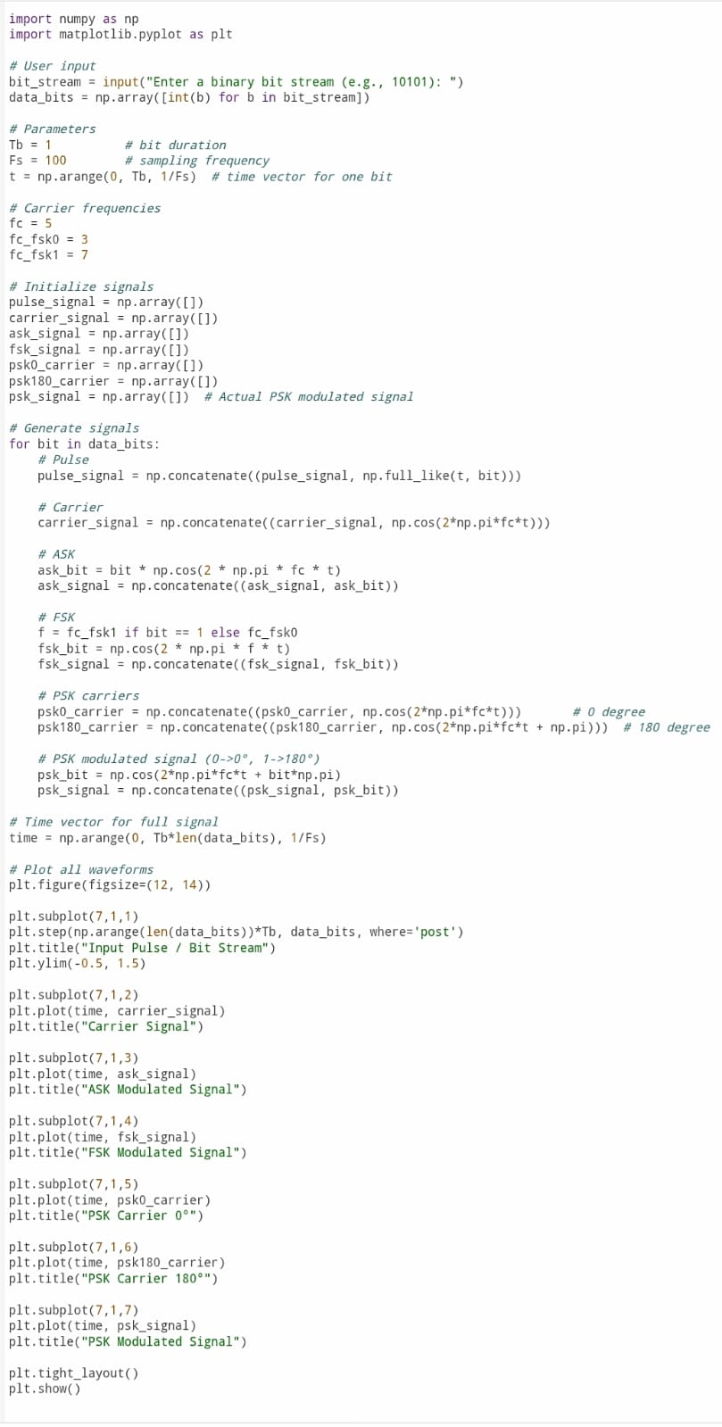

Enter a binary bit stream (e.g., 10101): 1011

